# MISSING

For this challenge the user is presented with a file folder with a web page that plays the popular 2048 game, although this has nothing to do with the challenge!

Viewing the hidden files in the root of the directory we will see that this folder is being tracked by git as the .git folder is present.

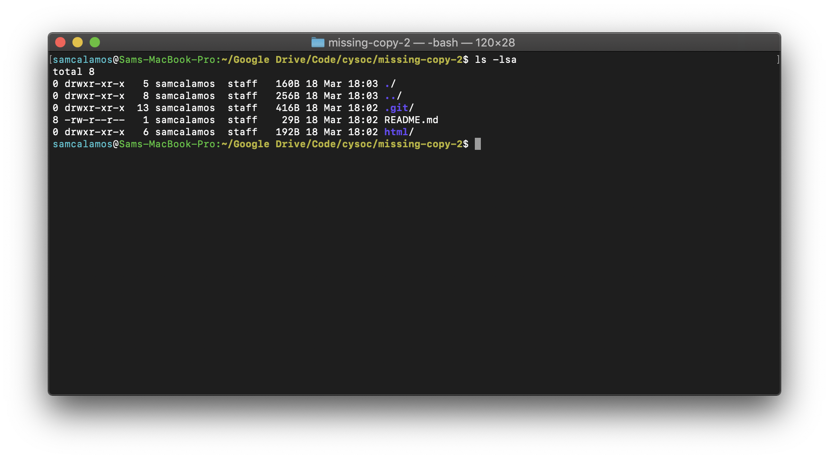

Viewing the commit’s of the folder shows that the developer has only 2 commits, the intial commit and then adding the 2048 game.

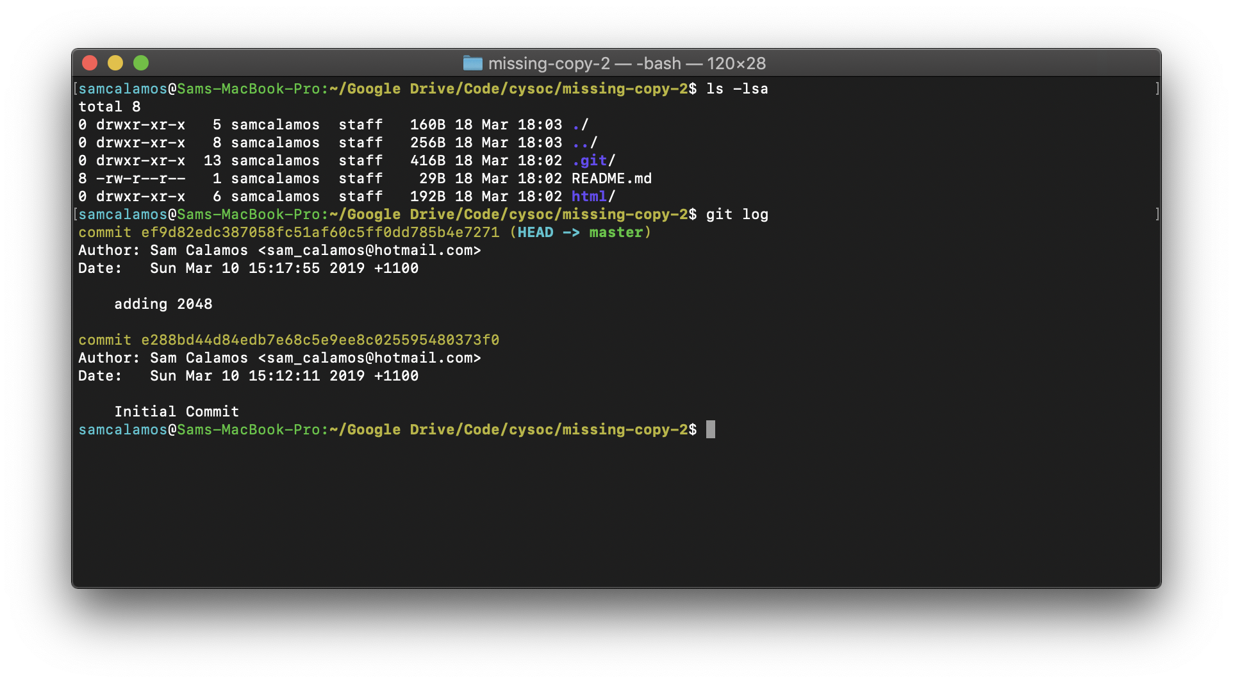

BUT!

Viewing all the commits using:  
“git log –reflog”

Shows more commits than the first command initially showed.

Git reflog is a record of all commits that are or were referenced in your repo at any time.

The interesting commit is the “hide flag” commit which contains the flag!

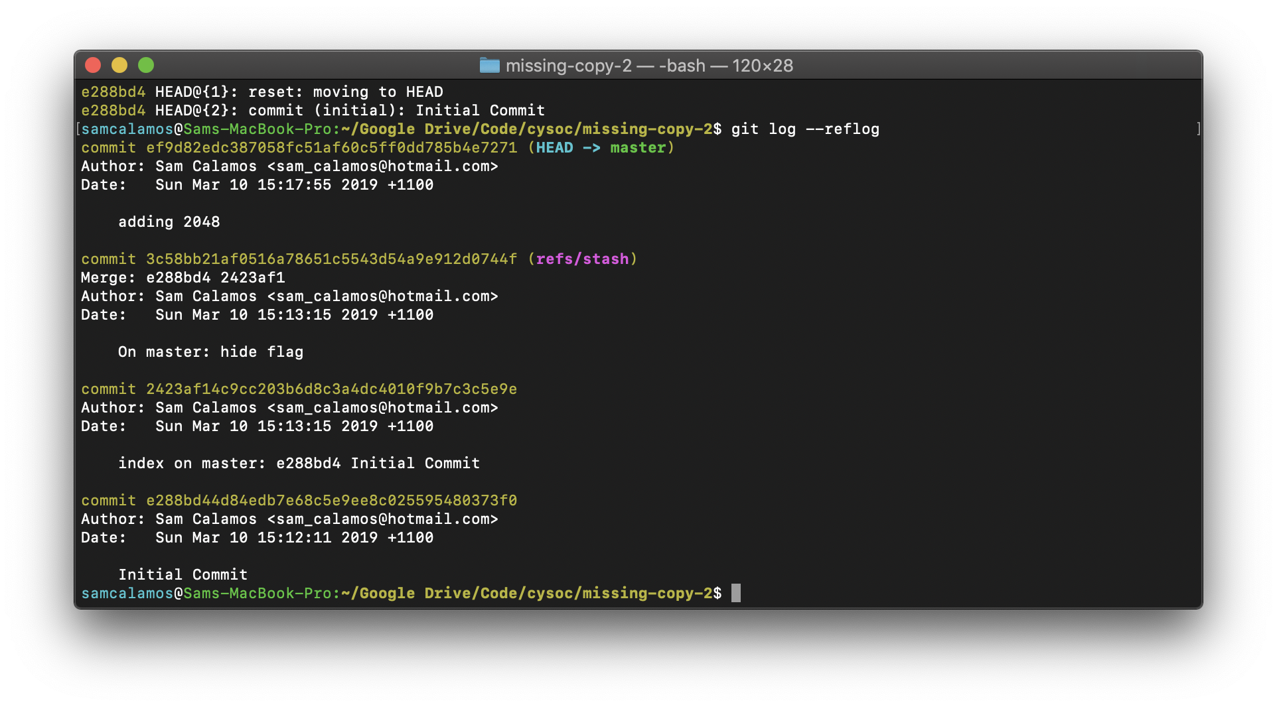

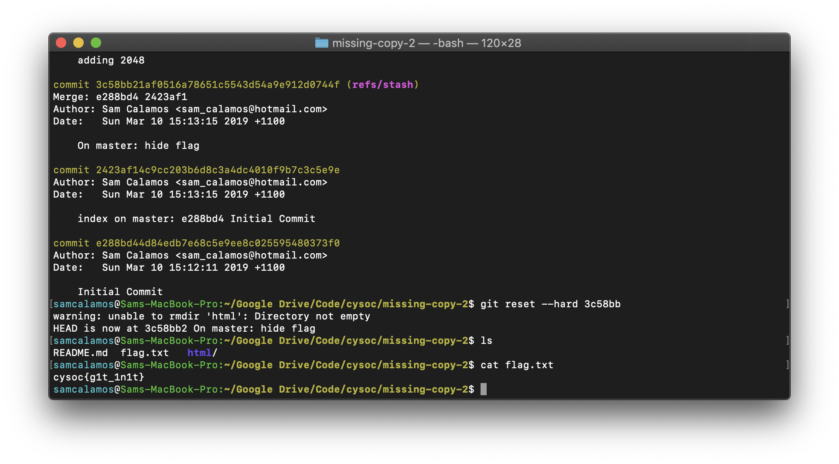

Hard resetting to that commit gives us the flag:  
**cysoc{g1t_1n1t}**